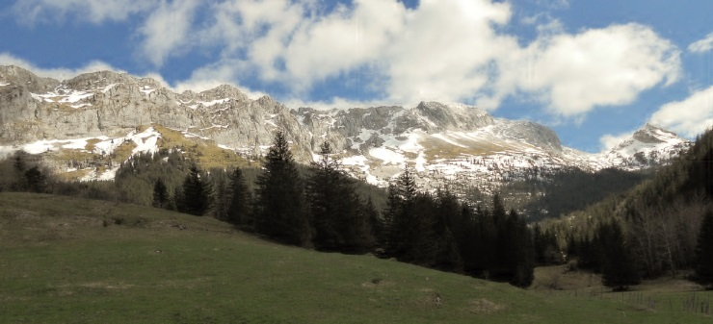
This year’s annual SCD school was the fifth organised by the Méaudre Reel Club in the Vercors in south east France. It took place from Friday 25th to Sunday 27th April 2014. Participants came from both France and beyond and a number were hosted by members of Méaudre Reel and their families. This weekend school has a devoted following, with dancers travelling long distances to be here year after year. It is easy to see why.
Méaudre Reel aimed this year’s weekend at those who wanted “to dance… in a friendly atmosphere…in the mountains in spring…to share a passion for Scottish Dancing…without fuss…just to have a good time.” And there is no doubt the dedicated organising team led by Sophie Marchand delivered what they offered.
The weekend began on the Friday evening with a dance which gave participants the opportunity to renew old friendships and meet new acquaintances. The dance was MC’d by the two teachers for the weekend, Laure Gardelle from RSCDS Lyon Branch and Tom McKinlay of the Paris Branch. Music was provided by Seonaid Lynn, Roddy Johnstone and David Foreman who had travelled from Scotland to play for the workshop. They were joined by Diana Sarran from Lyon.
Saturday saw a full programme of activity. The day began at 10.00 with a dance workshop taught by Laure and Tom with Seonaid and Roddy providing the music. Both teachers are fluently bi-lingual and that, added to their teaching skills, their knowledge of the dance and their ability to spot the dancer in need of help meant that all on the floor were encouraged both to deliver their best and to enjoy some quite challenging dancing aimed at intermediate to advanced dancers. Lunch followed – a buffet meal of local delicacies with home cooking much in evidence – and then on to afternoon workshops with Laure and Tom until 4.30.
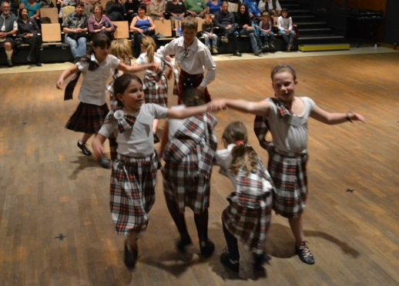
Participants then chose from a further SCD workshop taught by Tom, a Highland workshop taught by Laure and a music workshop with Sharlene Penman from New Zealand who had been playing in Lyon a few days earlier. Many of Tom’s students at this session were younger members of the Méaudre Reel club whose speed of learning was, according to Roddy who was playing for them, quite outstanding. Sharlene’s workshop concentrated on some of the music for the evening dance so that those who wished could play in with the band.
An evening meal, taken at a local restaurant, led on to the Saturday evening dance, managed by Laure and Tom with music supplied by the band augmented by Sharlene. But before the dance began the younger members of Méaudre Reel demonstrated their dancing skills in a programme devised by their teacher Sophie Marchand. Parents and members of the village community had come to support the children and it was a delight for all to see both the happy enthusiasm of the early learners and the high levels of skill of the more experienced students.
The dance that followed contained something for everyone. Of course the main focus was on Scottish Country Dancing but, with parents and village folk still in the hall, a few ceilidh-style dances had been included in the programme so that everyone could join in the fun. Music workshop participants came on stage to join the band for three dances ensuring that they too had the opportunity actively to enjoy the occasion and to put into practice what Sharlene had been teaching earlier in the day. It was a great evening’s dancing with a real sense of community.
Sunday saw dancers back for a further workshop with Laure and Tom and the musicians were back in session with Sharlene, this time concentrating on how to get “lift” into the music. After lunch came another feature of the Méaudre weekend as workshop participants went off together to visit a local farm and find out about their produce before setting out on homeward journeys or for an extended break in the Vercors - just one more demonstration of how far this Scottish Country Dance group is embedded in its local community.
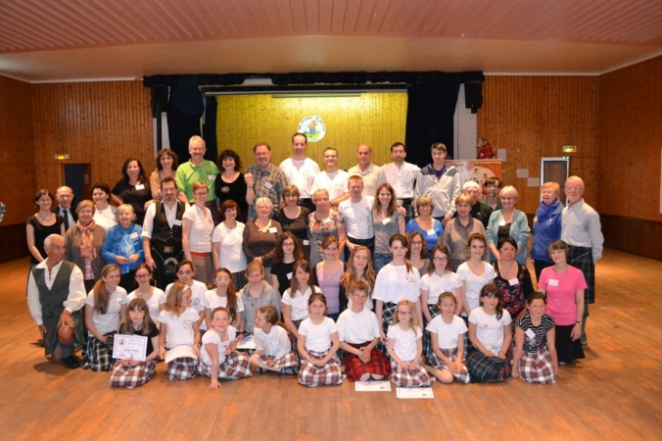
So what was it that made for such a good weekend?
The organisers do not just have a clear idea of what is to be done, but of the style in which to do it. They demonstrated the values of inclusivity, hospitality, and community that they share with so many rural Scottish venues. They delivered an event that was friendly, relaxed and enjoyable but that could, at the same time, challenge the dancer to extend their skills. They chose dance teachers who were well attuned to both task and values, and Méaudre Reel’s organising skills ensured the smooth running of a memorable weekend. Well done everyone.
To Sophie Marchand, her hospitable family and her group of dedicated helpers in Méaudre, nos félicitations et, à l’année prochaine.
If you would like to share in the fun, Méaudre Reel’s next annual SCD week end will be the first weekend of May in 2015.

